Banana Farm 2

When we saw first banana farm we said that we should find out more about practicalities in a plantation. So we did, we went to visit the second banana plantation and worked for two days with local people.
I would like to start describing the way from our guesthouse to the plantation. The first day started at 6.30 am when the tak-tak (full with workers) came to pick us up. The funny thing was that there weren’t only 15 workers but also three piles of boxes (lots of them!). Our backpacks went in the top of the boxes and we squeezed among the workers. The part of the way where it was asphalt there was not excitement and adrenaline. The fun part and the adrenaline level grew when we enter the village unpaved road. A previous night ran all the time so you can picture how the red and dusty soil mixed with water became. The wheels of tak-tak were going deep in the red mud and us, 18 people plus the boxes, plus the backpacks moving from one side to the other, sometimes bumping in each other. I admit that I panicked a bit when I saw that we have to cross the bridge that was covered completely by the river, and the water was flowing rapidly.
The workers did it and as that was the only way to reach the plantation we had to do it. First, it crossed the tak-tak (the boxes piles with our backpacks in the top were moving from one side to the other - every moment I was thinking that I will have to collect my wet clothes from the river) than the workers and then us. We crossed the first river.
Relief, we believed that there is no other river that has to be crossed. But we were wrong. After some other jumping and pushing the tak-tak out of mud there was other river. Well, that one wasn’t as wide as the first one, and as we succeed to cross the first one, here the emotions weren’t so big. We crossed the second one as well.
After one and a half hour we reached the plantation. Ole (one of the owner) prepared us the breakfast: sticky rice with mixed vegetables and chicken. After enjoying the delicious taste of food, we started to work. We had to help some of the workers to wash banana in a basin, cut them of the steam, throw the damaged ones and separate the bunches. It was a work that I never thought that is done with the bananas, I never thought that they have to be washed and seeing the basin full with floating bananas was a real view.
The workers from the plantation trained us how to do it better even though we didn’t speak the same language, more they didn’t understand English, and we couldn’t speak or understand Lao. But somehow we succeed to communicate. Our way of communicating was using our hands and body language.
Lao people were very curious to find out where we are coming from, how long we will going to stay in Lao, what is the next destination, etc. One of the workers came at work with her son, a very shy little boy that had a hobby in catching the butterflies and tied them with a thread.
Porvang (one of the workers) come with a pen and asked us to write in his palm our names, when I asked him to write his name he ran in Ole’s direction. We realized that he doesn’t know how to write with Latin letters and went to Ole to write for him on a piece of paper his own name and two others workers (Porvang, Tengxiong, Noy). The day past very fast, with people all the time around us to teach us how to do the work without cutting or producing injuries to our hands (the knives that we used to cut banana were very sharp and you could very easily cut your fingers if you didn’t pay enough attention).
The second day we had to start it with half hour earlier, at 6.00 am they came with the tak-tak to pick us up. That time was easier because the boxes were left at the farm so it was more space for us. The road was only fun, not emotions or adrenaline anymore – we got used already with the jumping and bumping.
The work that we had to do wasn’t so interesting as the previous one because we had to glue cardboard boxes. The process of doing it you could say that was a bit strange: we had to apply the glue on boxes, form the shapes and then stand on boxes 2-3 min till they got glued or to put some very big rocks on the parts where the glue was applied.
In the second day I brought to the kid that was playing with butterflies some sweets and a bottle of juice. He was so happy. For one hour he walked around and carried the bag with sweets. When he opened the chewing gum he brought me one as well. I was so impressed; even though those sweets were for him (and probably he doesn’t have too often sweets) he wanted to share it with me.
Later in the afternoon, after lunch break, we went with Ole to weight the small pigs (to check how many kilos they take every week) and then we took a walk through the plantation under the powerful sun, enjoying the palette of green colors, the mountain that is surrounding the plantation and the waterfalls coming down from the mountain top.
Speaking with locals we found out that Lao people likes to eat only fresh food (vegetable or meat), they don’t eat meat that is sitting in the fridge. When cooking, they don’t use salt but they use sugar and they like very, very spicy food.
For Lao people rice is the main dish and for some of them the only one! For the poor ones that can’t afford to buy meat or don’t grow any animals around the house, and when they don’t catch any hunt, they eat only rice with some spices.
As we saw in the banana plantation and when walking on the street, Lao people are shy, they look as they wouldn’t like to disturb you.
We wanted to go for at least one night to sleep in a local family but unfortunately, as Ole and Inger from HPP Laos informed us; we couldn’t because we needed a special letter from the Government. Ole asked one of his workers if he would like to host us but he refused, probably he was too shy or worried that he will not succeed to speak with us.
When we finished work we decided that we have to go on with our trip, down to Pakse. How there are not bus stations, the bus stop everywhere, we stayed on the street waiting for the bus. Janis and Evelina were sitting on a bench and because I was standing at the edge of the road a local girl brought me a chair. I was so surprised by her act and in the same time I felt a bit strange to sit on a chair at the edge of the road, trying to hitchhike. As I see this happening more and more…you never know what the next moment it’s bringing!
We are grateful for the opportunity to stay and work with local people, to see how they are living their lives, what implies for them to reach the work place, what they eat, what are their worries, etc.

!!! Tak- tak is a kind of tractor, is called iron buffalo in Lao and people are using it for transport (goods, people, animals, etc) or to plow the land in the village areas.
!!! Tuk-tuk is used in cities as a taxi or public transport.

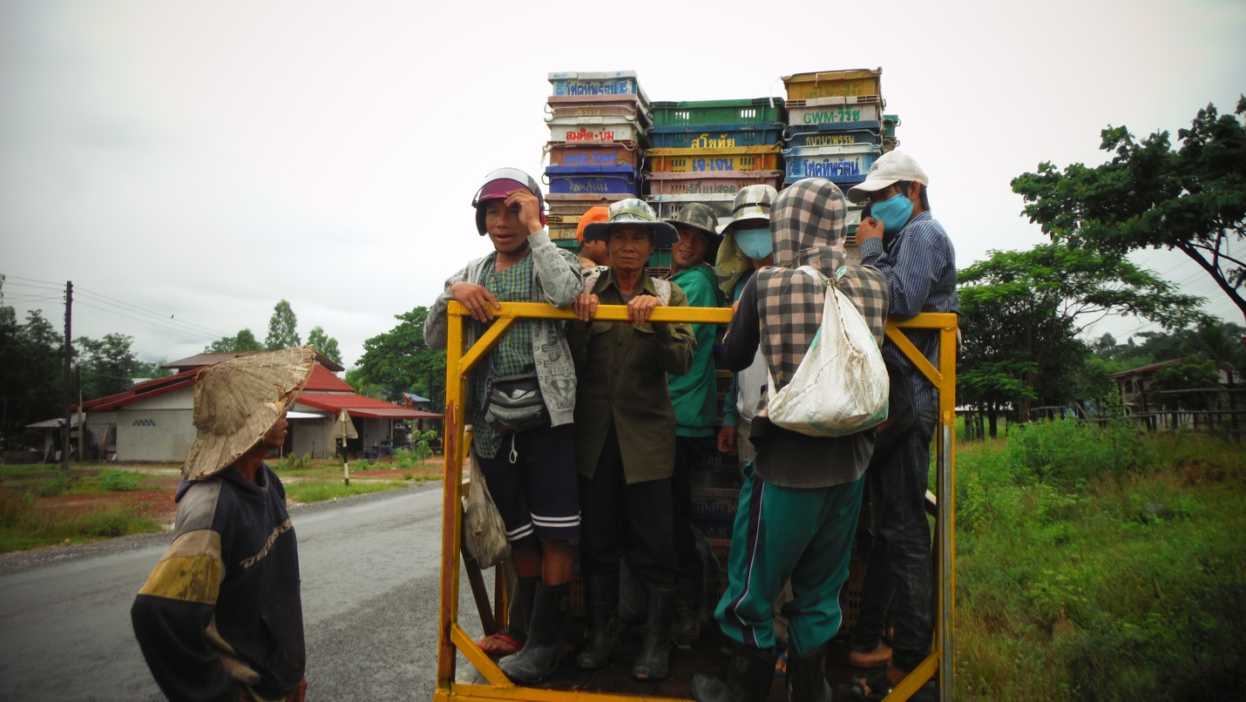
We actually fitted in!

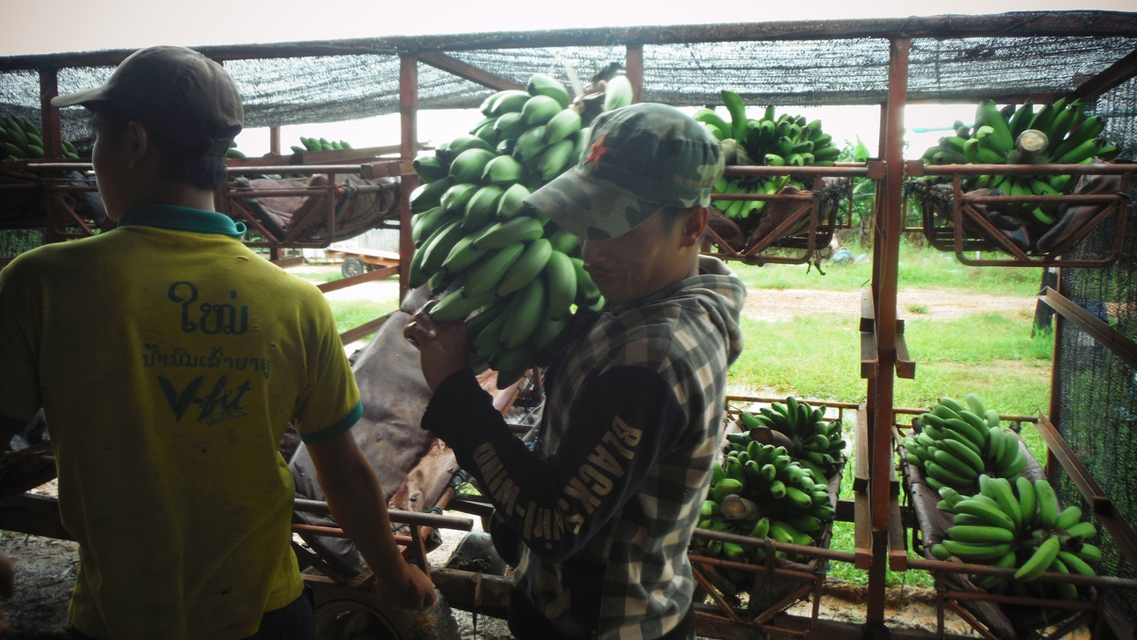
Bringing banana from the plantation to be washed and packed
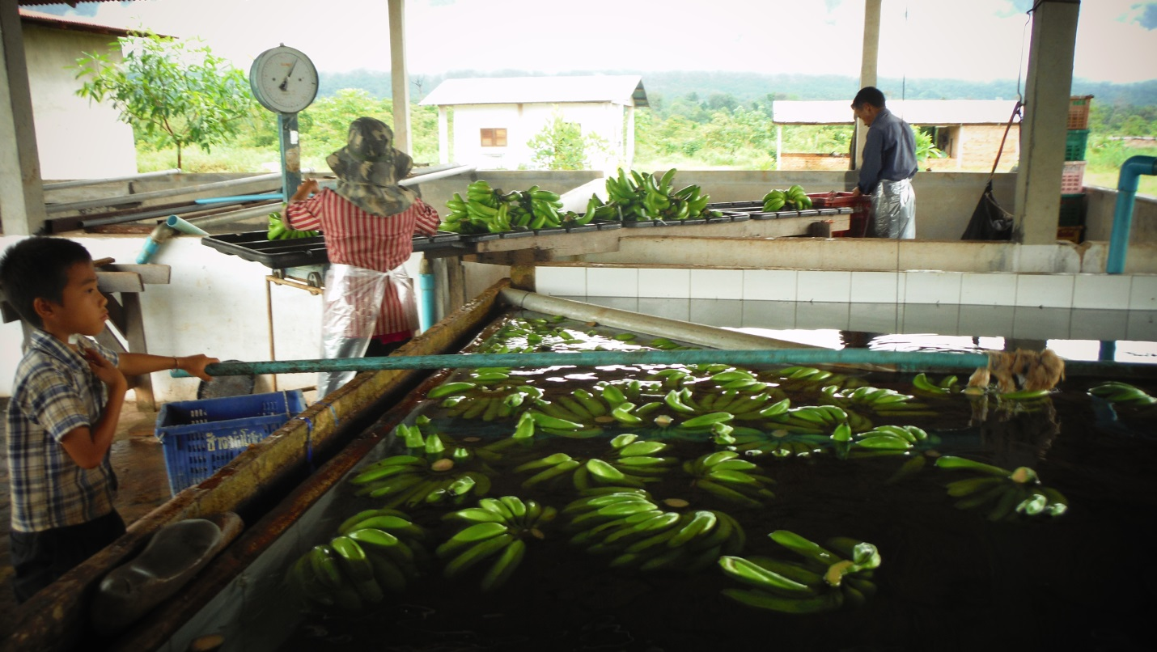
The basin where bananas are washed and cut off the steam

Weighting the pigs

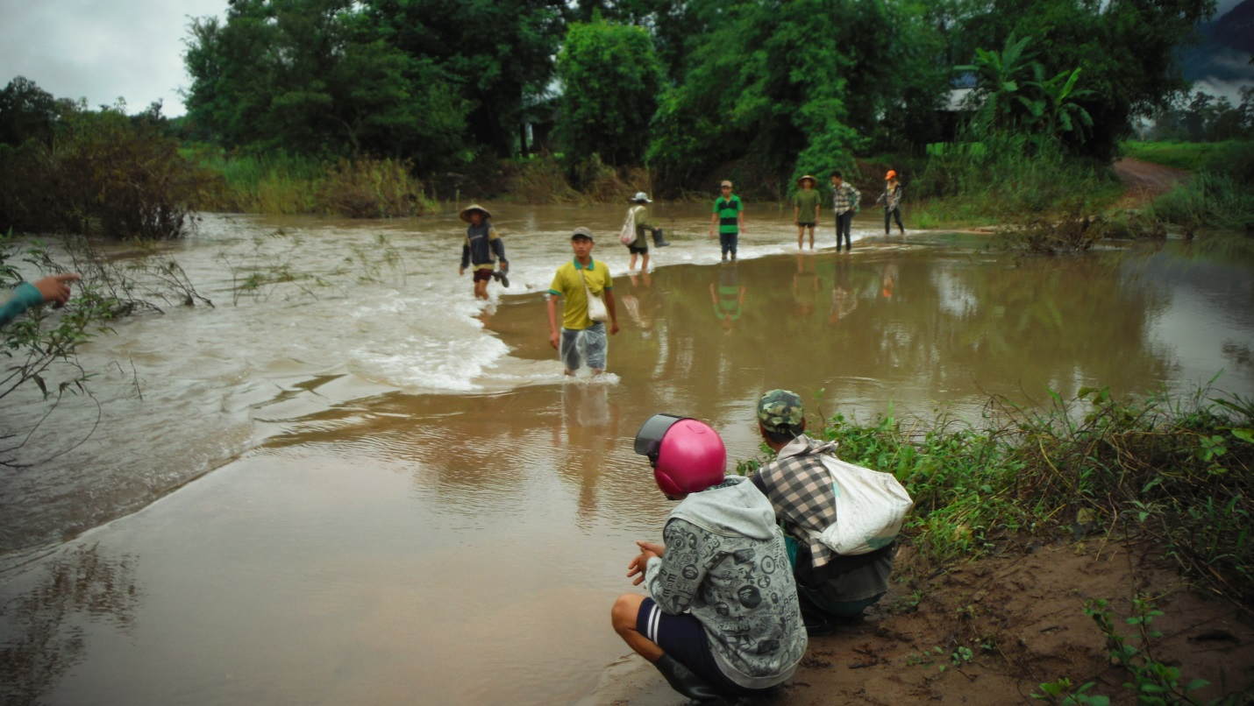
First river to be crossed for reaching the banana plantation

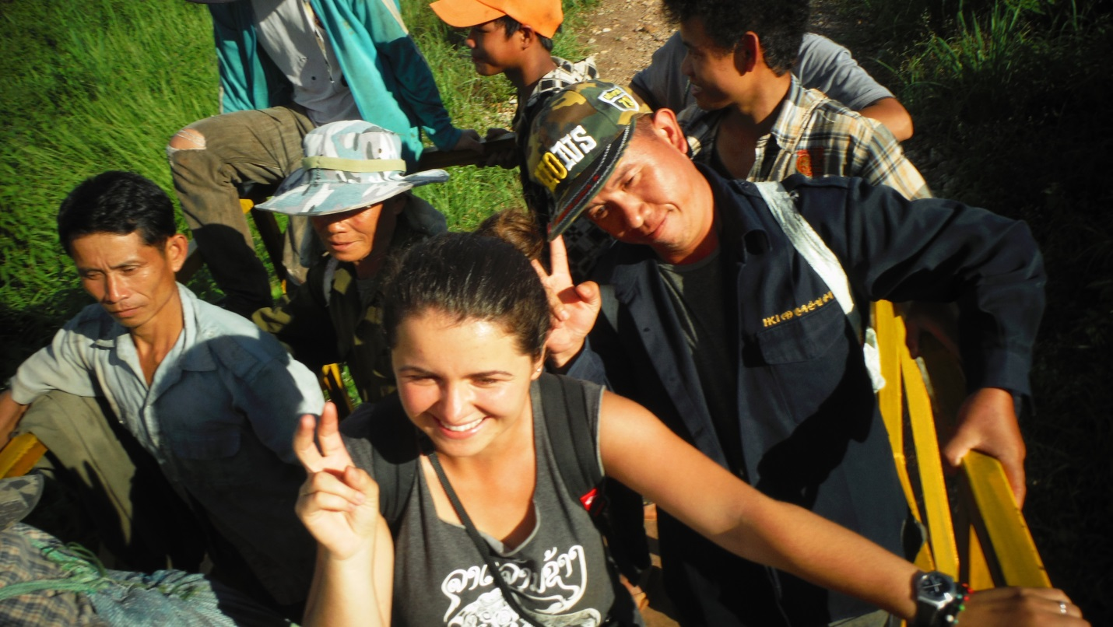
Afternoon, going home after work

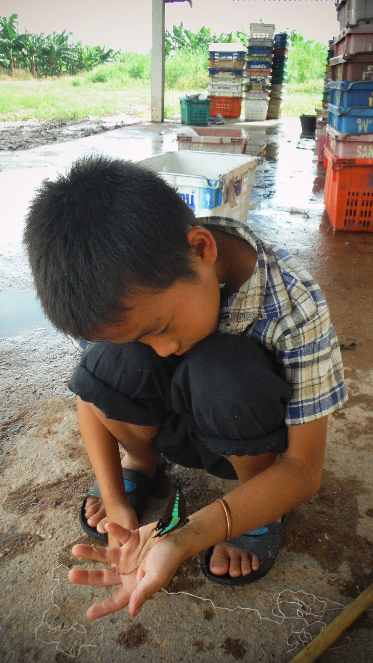
The little boy playing with the butterfly
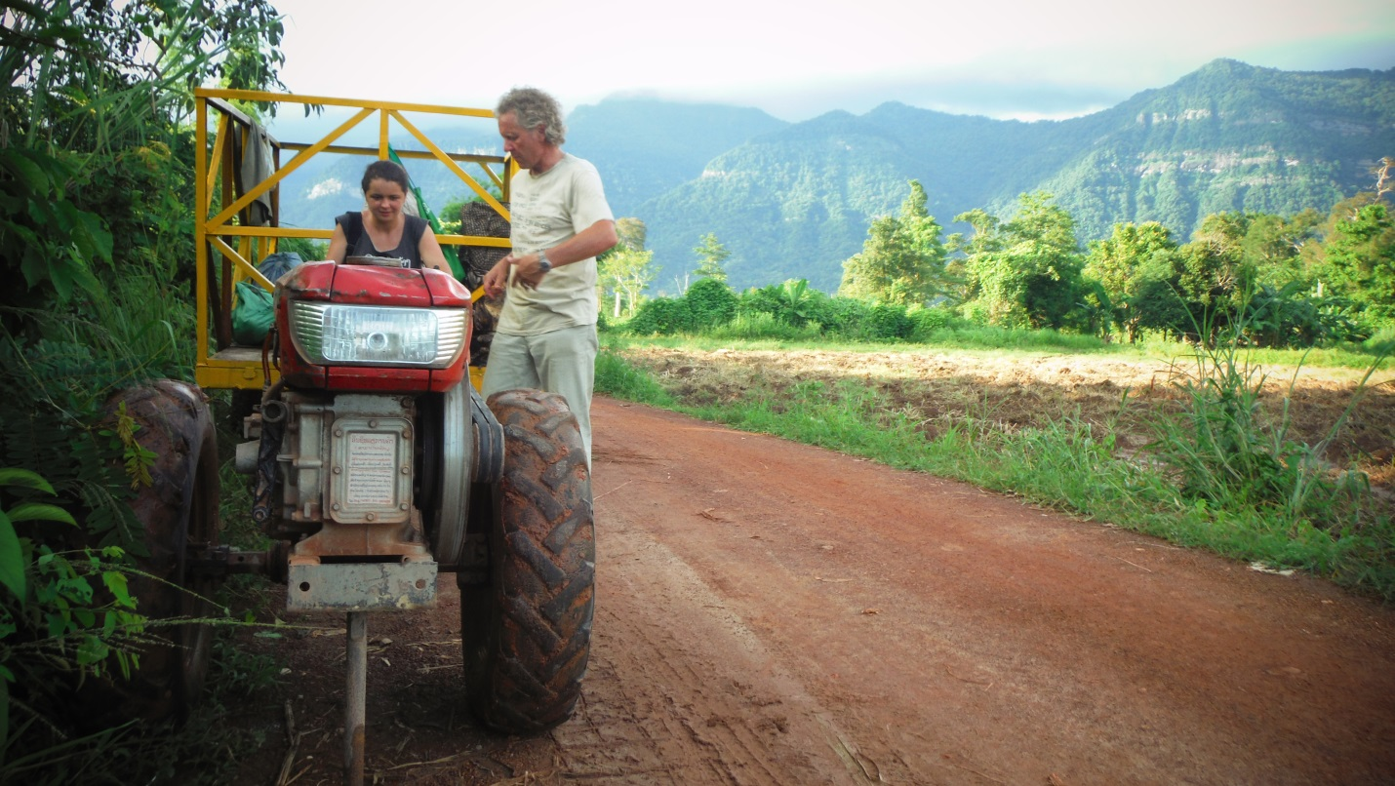
Trying to understand the system
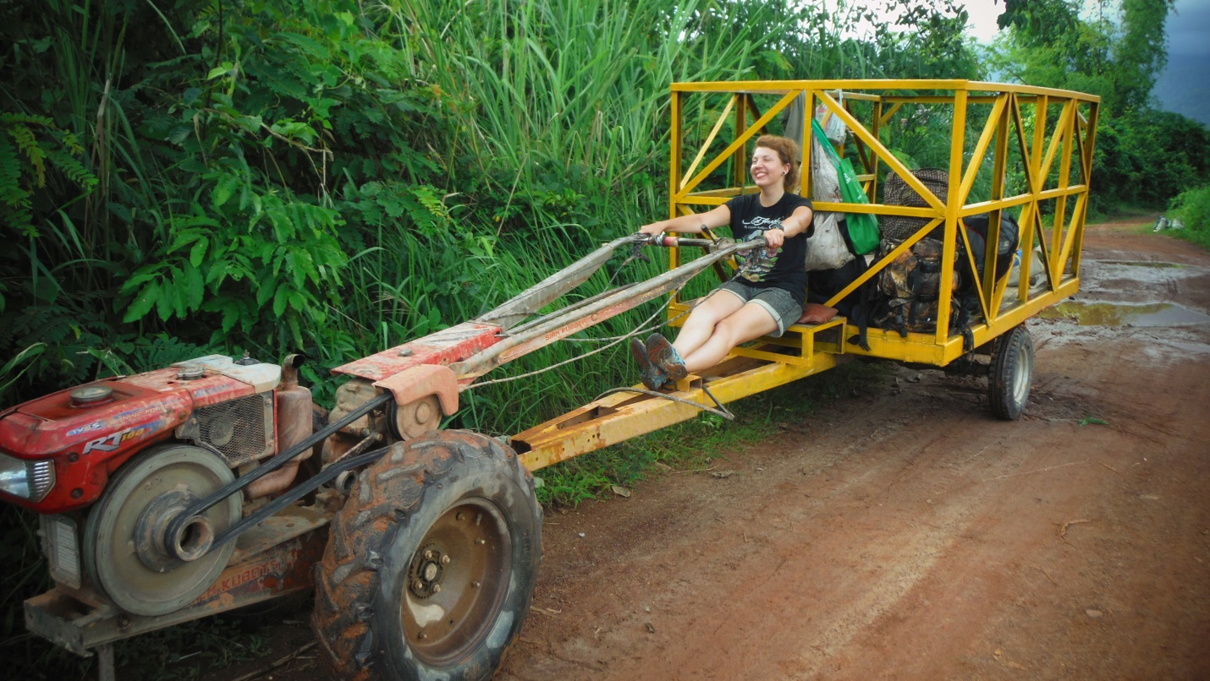
The tak-tak and Evelin enjoying the landscape
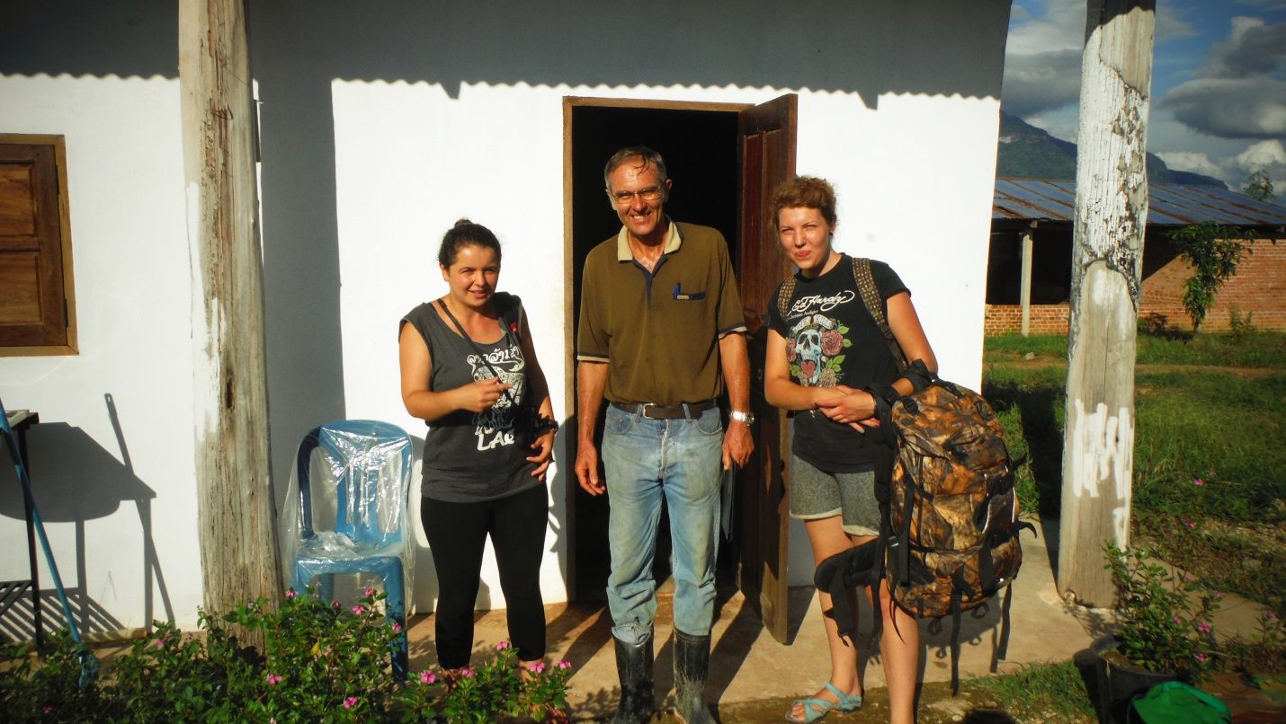
Saying good bye to Ole (on the next time)!

