Mathare Slum- fighting with the poor

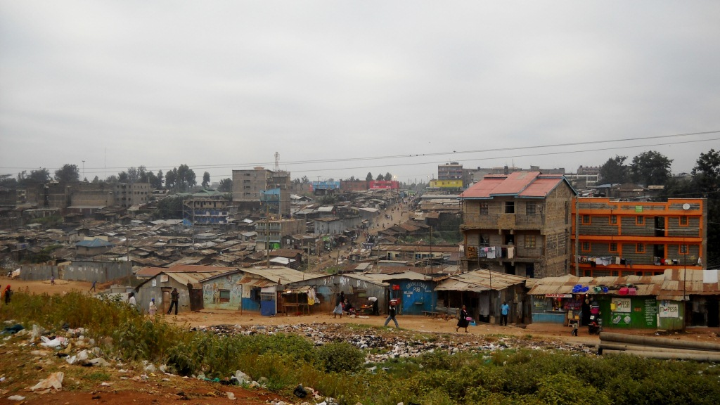

Mathare is one of the biggest slums in East Africa and the oldest in Kenya, counting officially around 70.000 inhabitants and still expanding, but in the community the rumors are that the population is around 500.000 living in around 25.000 households. Situated only 5 km from the center of Nairobi, a part of the world that nobody remembers, Mathare is bursting with dirt, poverty, overcrowd, misery, nevertheless life. As all over the internet the awareness is raised concerning visiting the place as considered dangerous and inaccessible, we try to get in contact with some organizations that can get us inside. We find MEO Kenya and send an email about our interest in visiting and working inside the slum. Bernard Nyachieo replies the very next day and we meet him and establish a one week plan of involving in his work.
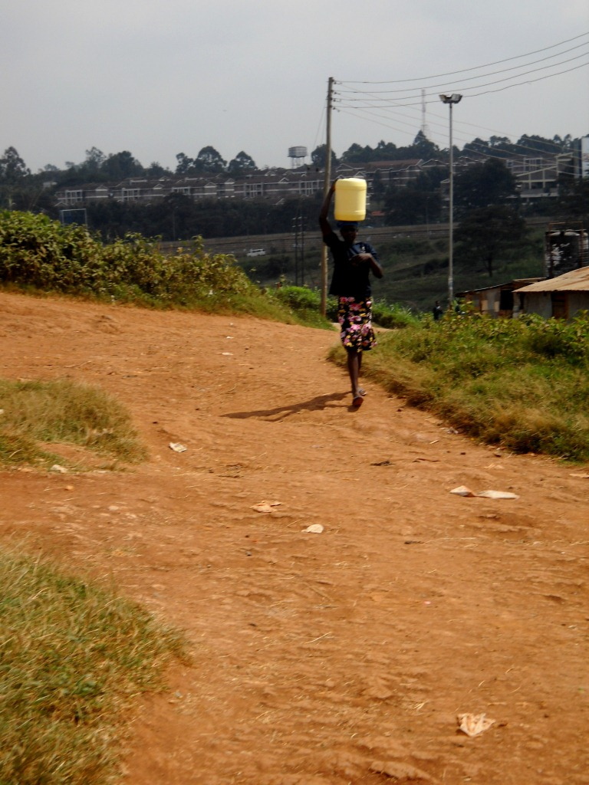
In the first day we stepped the path that leads to the slum, we were astonished. There are fields of corn around and we have to pass a small dirty river where clothes are washed and hanged or left in the bushes to dry. Garbage all over, a smell of lost hope and misery follows us all the way…As we go more and more inside, we hear children voices asking us at unison ”how are you?!”, a melody that will greet us every morning in the next 5 days and people saying ”muzungu”(white person) and “welcome”. It is 7 o’clock in the morning and people doing their daily chores are greeting us from everywhere. The landscape is overwhelming and not in a positive way…we feel totally helpless.
We find out that life is a burden inside the slum, valued at less than a dollar per day. Even the poorest people have to pay for everything, from using the toilet to having buckets of water at 2 shillings per 20 liters. The women are going to the place where there is the tap water and fill their buckets and carry them through the field to their homes.

All the huts are 10 feet per 10 feet covered with metal sheets and most of them lack electricity. There are also some flats, but very few of them can afford to live in them, even if the conditions are as low as in a hut, those who live there are considered already rich comparing to the other slum habitants. The police and the elder’s council are the rulers and more than everything the owners of the land make the law. Renting the hut from the owners doesn’t make the slum people being part of any aid coming from outside. Bringing aid is usually made in two ways either through the church either through the owners…and the owners are taking everything. When Red Cross came to bring supplies, as food and washing soap, bed sheets and blankets, because none of the people living inside could show a legal document the owners took over. It is almost
impossible to find somebody that owns the small land where his family is living, as the owners are living somewhere in the city taking advantage of their poverty. Owning a piece of land costs 1500 euros, sum that nobody living inside can afford, and the rent goes from 1000 Kenyan shillings to 3000 per month. Most of the people are working as vendors in the streets or trying to do small chores in the rich people’s houses like washing clothes, house holding, or the lucky ones have small businesses around the slum where they sell different kind of things that they find or can procure easily. As we find out the story of a woman who is everyday going to a restaurant in the city and collecting the left-overs of bread and sells them inside the slum or around at small affordable prices. The slum is surrounded by a field of corn, where some of those who were lucky are working and take the corn, transform it in flour for ugali and sell it to the others. Some of them trying to make some money build corn mils inside the house and put the flour outside the door and sell it.
We find inside the slum a small restaurant, and by small we mean really small, full of flies and with two benches and a long table where people are eating. Across, there is another small shop where somebody is selling bananas at a price of nothing.

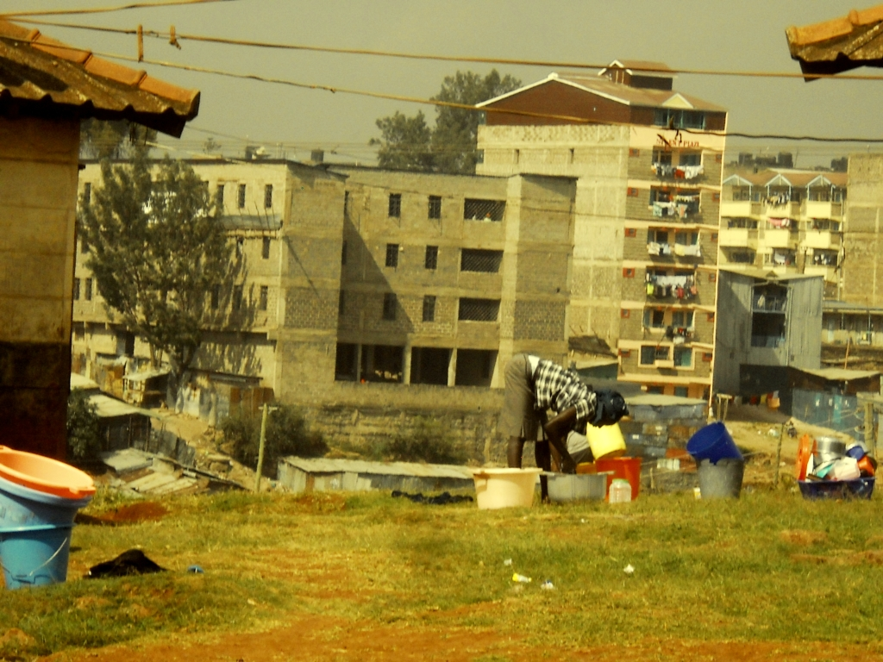
Most of the inhabitants are
women who were left by their husbands with a lot of children , most of them are under 30 years old. As we hear Bernard saying, behind everywoman that lives in this slum, behind every woman’s tears there is a man who deceived her. Usually the women are going to work in the mornings and live the kids in the slum. There are few schools where the kids can
go, but they are also requesting money, and from the small income they cannot afford to let their kids have some education. Most of the families are mono-parental, single mothers, the husband left or died and they live with the kids. The most terrifying stories we heard about mothers dieing and kids left behind have no other choice but wandering on the streets of Nairobi, begging for food or money, stealing, etc. because the owners of the slum huts will never let the kids living in the houses if nobody can pay rent for them.

People’s stories

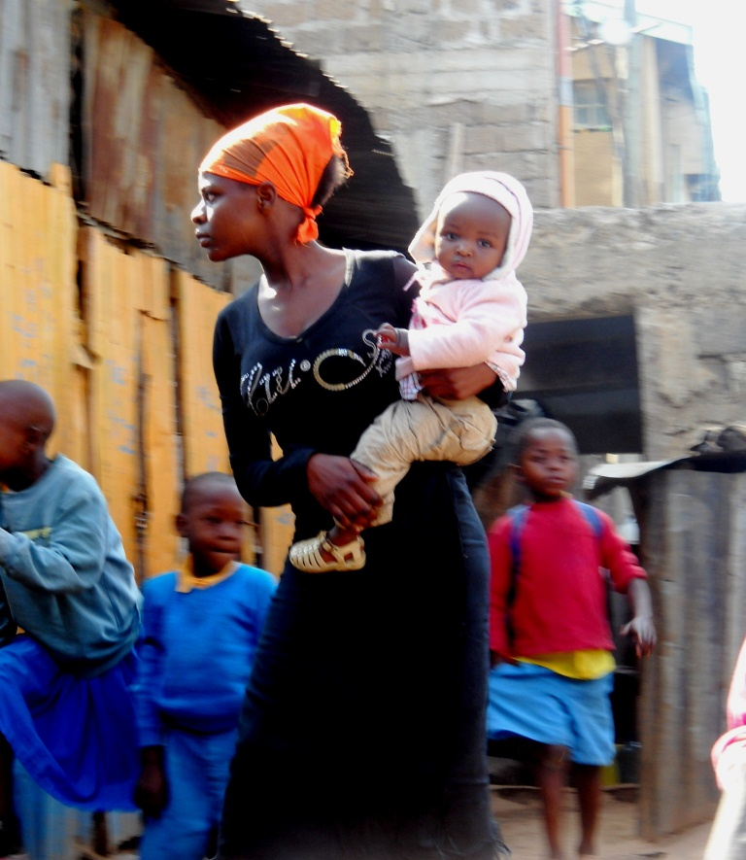
We hear about Linda, a single mother with three kids who is working for a family in Nairobi. She is washing their clothes for 1 dollar per day. She is complaining that she is forced to use chloride for washing and her hands are damaged, but she has no other option. Her husband left her few years ago, run away to another city and she had to take care of the kids. Few weeks ago her husband came back and took two of the kids to live with him and his new wife. The mother cannot afford to do anything, but Bernard is trying to put her in contact with a school nearby her home village and some children care organization that can help her bring back her kids.

Lidia
She is a woman who was living all her life in the slum. But she was fortunate; her family could afford to keep her in school until second grade. Now she is volunteering at MEO Kenya, Bernard’s organization and she is trying to teach the children everything she knows. Even if she has the status of a volunteer teacher, she receives 3000 shillings per
month, money that can help her live with her husband in a small hut in the slum. She is
open and joyful and talks about God who is working through everything. She cannot imagine how life can be like outside the slum, but she would like someday to come and visit us.

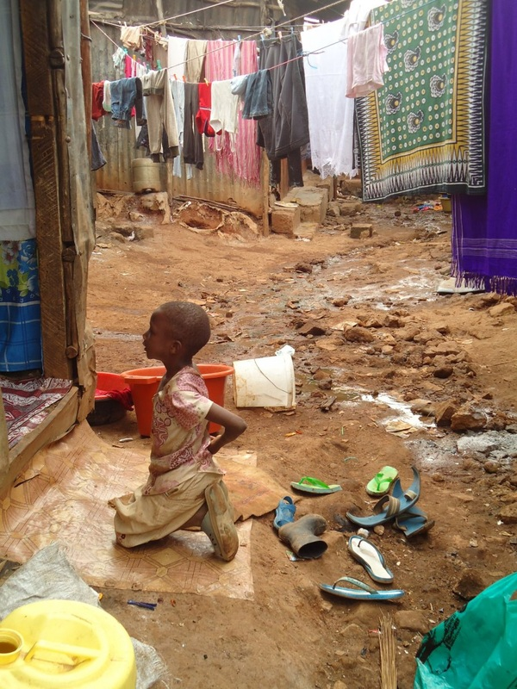
It is astonishing how people can still keep their good mood and faith in a deity when living at the edge.

MEO Kenya, a hope inside the slum
“I need volunteers to help these people develop through education, I would even like to receive volunteers from Humana” (Bernard O. Nyachieo )
http://mabawaorg.weebly.com/index.html

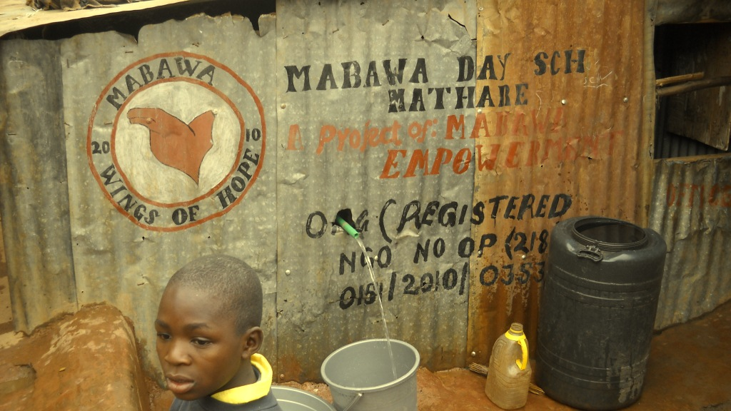

When we met Bernard he was really happy that we wanted to involve in the slum and in his organization because he needs people that can volunteer to teach. He was born in a village near Kisi(village that we discovered at the end of the week) and he was very poor, but when he discovered the slum, he realized that there are people out there living even in much more poverty than him. He finished his second grade and he started to work, he was dreaming that one day he will start an organization for the people that need more help than him. He met Esther, a Dutch nurse who was in holiday in Nairobi and he shared his dream with her and she gave him 280 euros with which he started Mabawa School in the slum. He rented a hut for 85 euro per month and started to bring children in for the first 5 grades. Because he believes in development from inside he is trying to use funds
from inside the slum. Now half of the funds are coming from Esther and half from the fees-the families who can pay are requested to pay 900 shillings per year per child. The MEO Organization has now two parts, one part school and the other part baby care. Till August, Bernard is planning to extend the organization to helping women develop and acquire skills. Therefore he made a huge detailed plan for Laura Institute which will have two parts- Dana salon, where women will be trained for hair cutting and facial beauty, manicure and pedicure and Esther Tailors, where women will receive skills in sewing, so they can open some private small businesses inside their own homes. It was amazing how Bernard was telling us that he has plans for the organization for the next 21 years and he is waking up everyday at 4 am and starts to work on them. He came to us one day and started to speak about the new institute and the next day he had already everything written down. We helped creating some logos for the new institute and gave him some advice. As he was telling us he really needs volunteers that can involve in helping with the children education and with the next projects and he is trying to persuade us to send our team mates to his place or he is even willing to start cooperation with Humana.

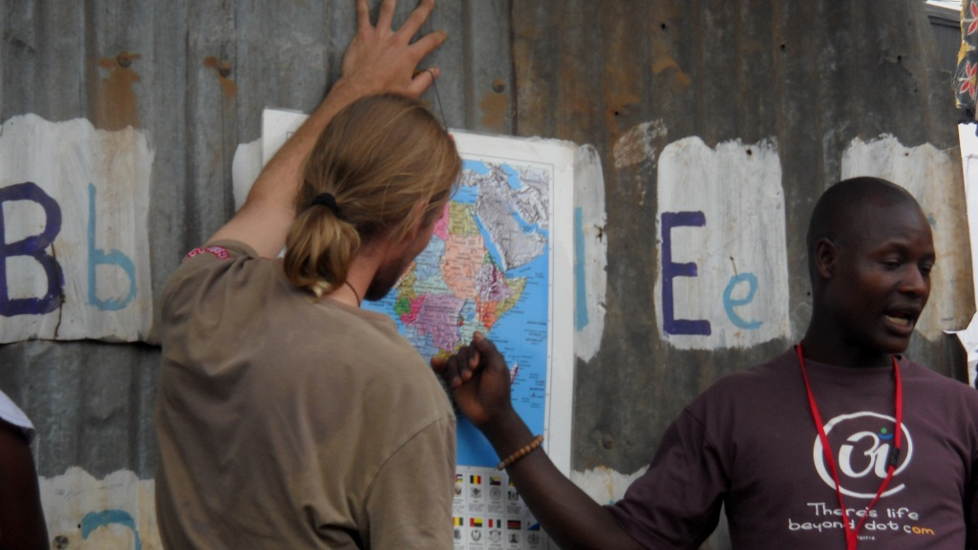

Volunteering in Mabawa School

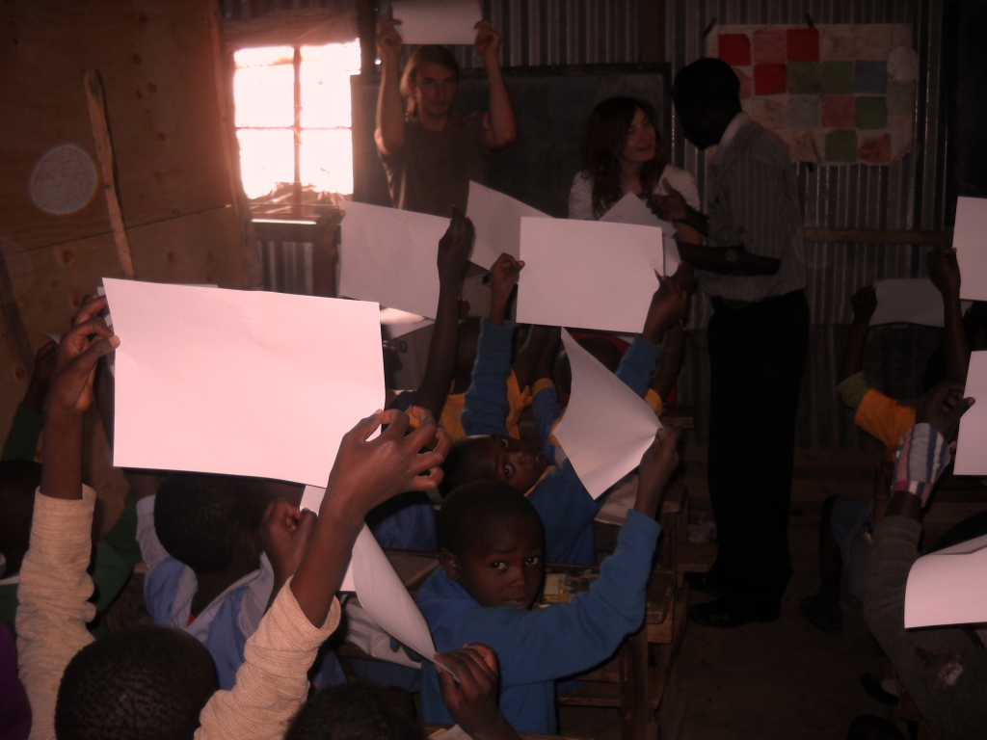

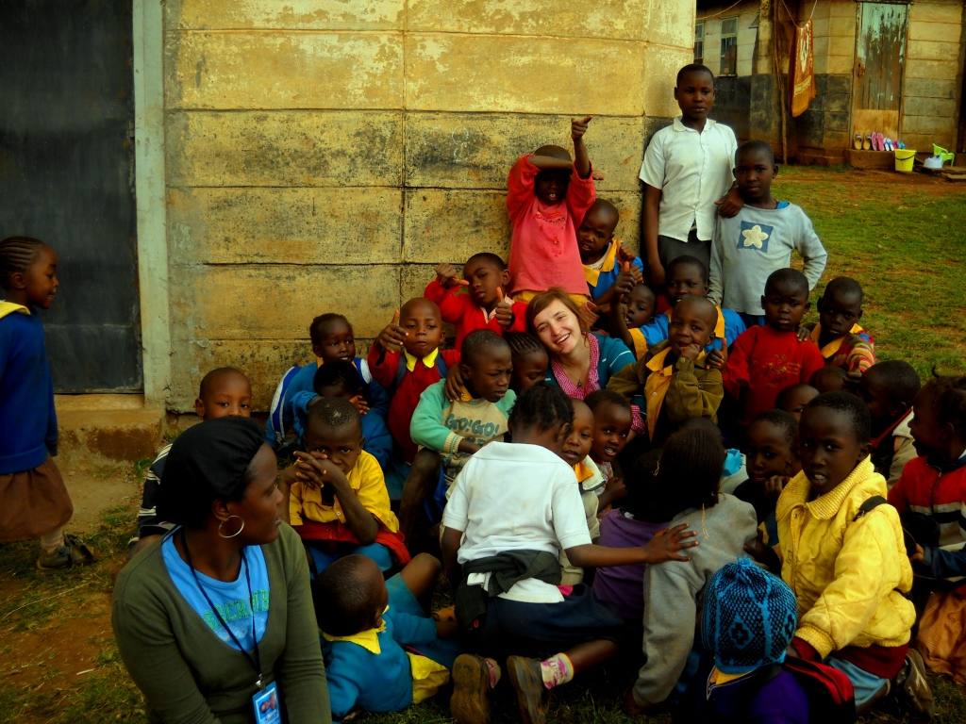

We spent 4 days in the slum. Our day started at 7am and finish at 5pm when we go to spend the evenings with Bernard and his family. We took the matatu and drove 15 minutes till the slum. The cold mornings woke us up and gave us energy and a huge influenza at the end of the week. When we reach the school the children are already there as they start their lessons at 8 or 8.30. We had English classes, Math, Science and Drawing with 2nd, 3rd and 5th grade. The children were very communicative and involved. Most of them don’t know how to count or to spell, but almost everybody knows to speak in English.
Everyday after the first morning class they have one hour of sport and we join them on the field situated across the school between a church and some police abandoned buildings.

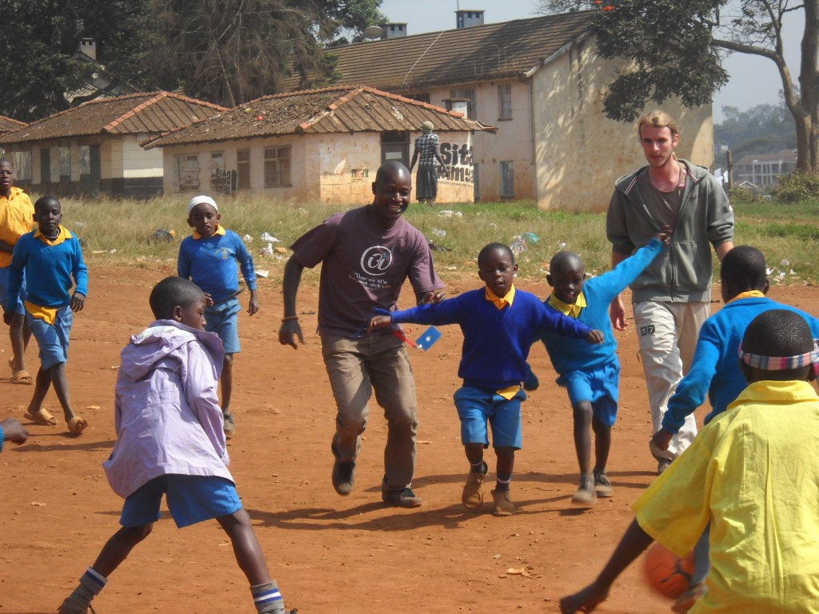
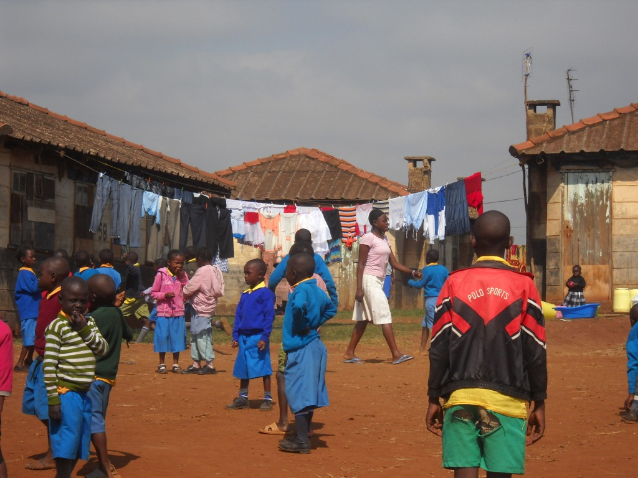

The joy fills the air and the laughter and energy makes us join them. We teach them new games and they teach us their games and we play until they are overtired. The feeling is overwhelming and shocking, as even though they already know us from the classes they surround us all the time staring laughing fighting between each other to touch us.
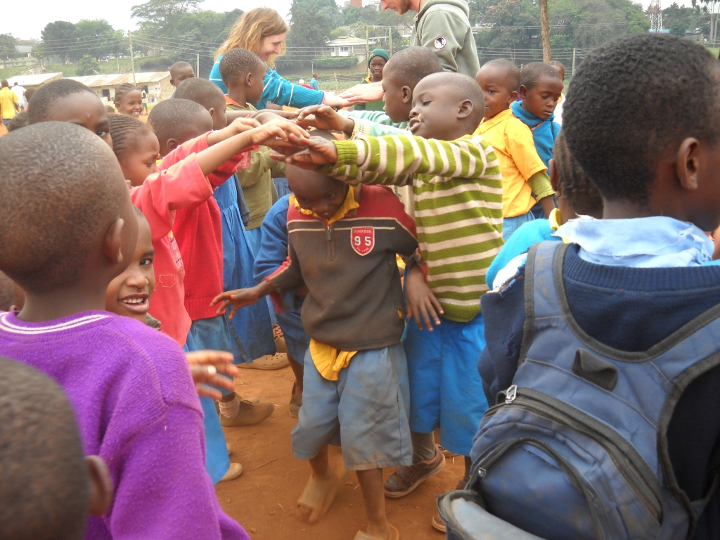

Usually at midday they have lunch, some of them are eating in the school, the never-ending rice with beans. Before eating, together with Bernard we are trying to teach them to clean their hands with water and antibacterial gel
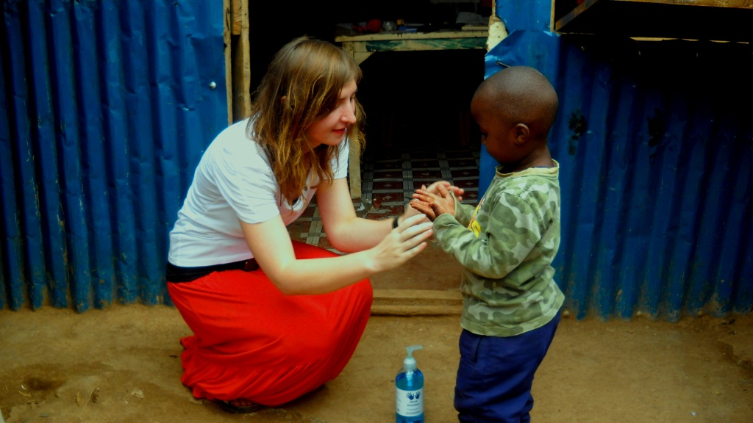

The kids are coming in the row as they already know the rule and we are helping them.

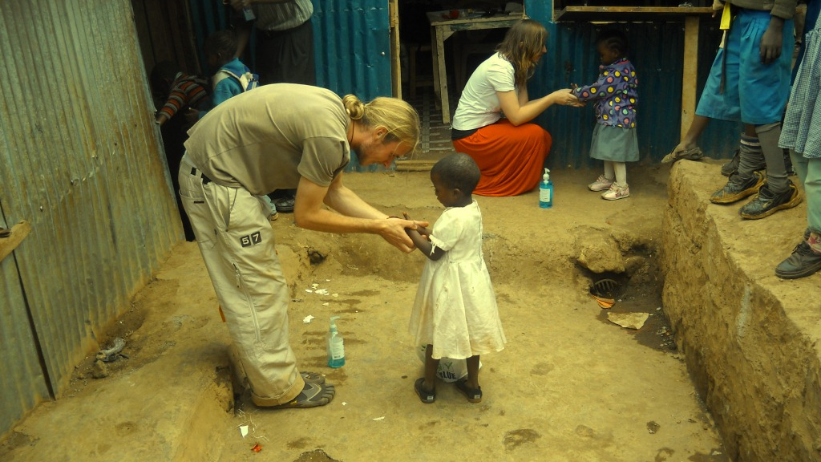
The classes end at 5 pm, but some of the children join the dancing or science clubs and every afternoon they brought us some of their dancing parts trying to show us their beautiful culture and their knowledge.
As a response to their evening art programs we are holding an evening presentation about Europe and together we try to compare traditions and culture and we listen to their amazing questions about muzungus and we try to make the picture of the world we are living in as clear as possible for them.

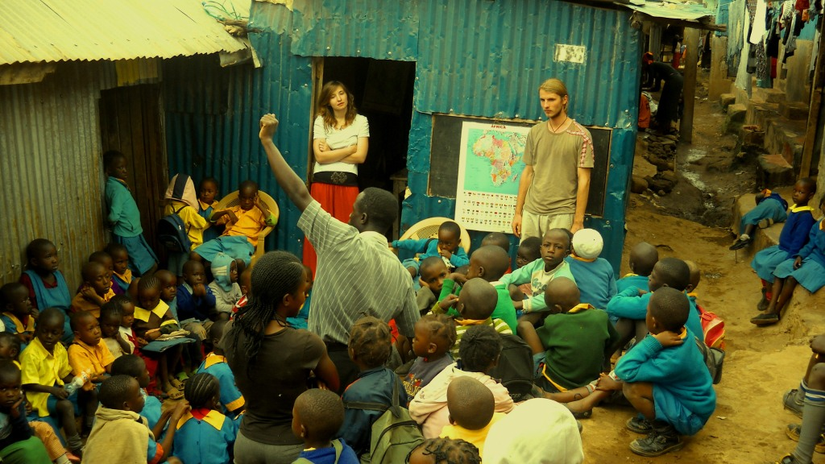

At the end of the week when we have to leave the slum behind, we feel the sorrow filling our hearts and we are not even strong enough to say goodbye.
We had one of the greatest experiences of this travel while working in the slum. We learnt a lot of new things bout Kenyan culture but most of all we lived with the real poor. Because nevertheless, the rest of Africa we see in the villages or in the cities is poor only conform to our standards, but the people living in the slum are for us the real essence of Africa and the voices of misery and sufferance that the rest of the world should really be concerned of. Hakuna Matata!



